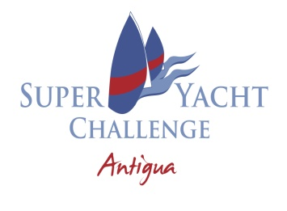
DAILY DECLARATION FORM 2026
SAFETY ITEM | DETAILS
A yacht did not answer, or did not answer in a timely manner, on the safety channel
We were involved in a safety related incident
We observed a safety related incident

We had a man overboard

Someone was injured

We had a breakage

We put our engine in gear and/or used our thruster while racing
We took a penalty

We request a rules clarification meeting

We intend to file a protest

WIND DATA
LEG | LEG DESCRIPTION | TRUE WIND SPEED | MAGNETIC WIND DIRECTION
Start
1
2
3
4
5
6
Finish
Yacht: Date: Race:
Submitted by:

