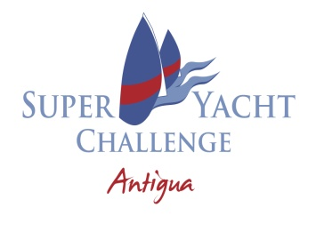

Sailing Instruction Amendment # 2
13.3.2024 at 1500

Add to SI Attachment A Notes the following:

- For Courses 1-13 all marks are rounding marks, except Start/Finish ODM which is a passing mark.

- In accordance with Sailing Instructions 7.1. The starting sequence for Thursday is as follows:

STARTING SEQUENCE

YACHT NAME | START TIME
ZIG ZAG | 00:00:00*
NAMUUN | 00:04:00
ADELA | 00:08:00
FREYA | 00:12:00
HUMMINGBIRD | 00:16:00
ZEMI | 00:20:00
HETAIROS | 00:24:00

* 00:00:00 is the time of the starting signal for the first boat scheduled to start

Hank Stuart
PRO

Posted on official notice board at 13.3.2024 @ 1500

