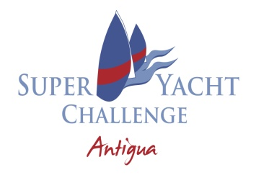

Sailing Instruction Amendment # 1
12.3.2024 at 1200
Sailing Instruction 7.2 is changed to read:
The Lat/Long coordinates for the signal mast is:
017N00.038
061W45.641

Hank Stuart
PRO
12.3.2024 at 1200

