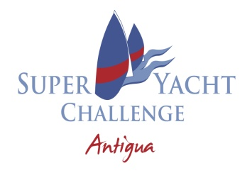
13TH SUPERYACHT CHALLENGE ANTIGUA
NOTICE TO COMPETITORS NO. 2
12.03.24 @1200

- The starting sequence for the Round The Island race is as follow:

YACHT NAME | START TIME
HETAIROS | 09:00:00
HUMMINGBIRD | 09:04:00
FREYA | 09:08:00
NAMUUN | 09:12:00

Hank Stuart
PRO
12.03.24 @1200

