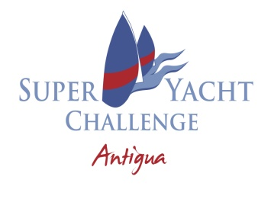

13TH SUPERYACHT CHALLENGE ANTIGUA
NOTICE TO COMPETITORS NO. 3
13.03.24 @ 0730

