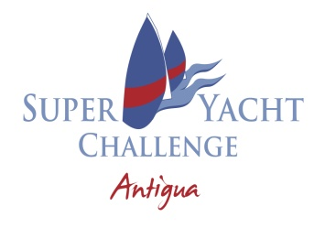
12TH SUPERYACHT CHALLENGE
ENGLISH HARBOUR, ANTIGUA
6 to 12 MARCH 2023
NOTICE TO COMPETITORS NO 1

There will be one class only – Buccaneers.

Willii Gohl
Race Committee
7.3.23

